|  |  |  |
| --- | --- | --- |
| **Primary Media Contact:**  Advantech Europe  Lucia Falena  +39 029 544 9644  [Lucia.falena@advantech.it](mailto:Lucia.falena@advantech.it) |  | **2nd Media Contact:** |

**Advantech Launches Upgrades to the PPC L128 and PPC L61Panel PCs**

*May 31, 2011* – Advantech(2395.TW),a global embedded computing leader, announced a new generation of its PPC-L128T and PPC-L61T panel PCs. Both models are fanless and well-suited for use in Human Machine Interface (HMI) applications in factory automation, machine automation, equipment and intelligent services. The new models have been enhanced to provide better performance as rugged and compact HMI solutions.

**New Generation PPC-L128T: More Robust and Less Expensive**

The new PPC-L128T (R81) has the same integrated features and ergonomic design as its predecessor. The new release has been enhanced to provide better communications, an upgraded panel, better environmental support, and a more resistive touchscreen, making it even more robust—all at a price that is significant lower than before. Some of PPC-L128T’s significant benefits are listed below:

1. **Supports Win CE 6.0** – A more compact system enables better productivity.
2. **High Brightness LCD** – Brightness is enhanced to 600 cd/m2, with full support for semi-outdoor applications.
3. **Anti-Corrosion Display-** The system can also be used in critical environments such as vulcanizing machines.
4. **More Competitive Price-** The retail price has been decreased to encourage customers to experience the brand new, powerful PPC L128T Panel PC.

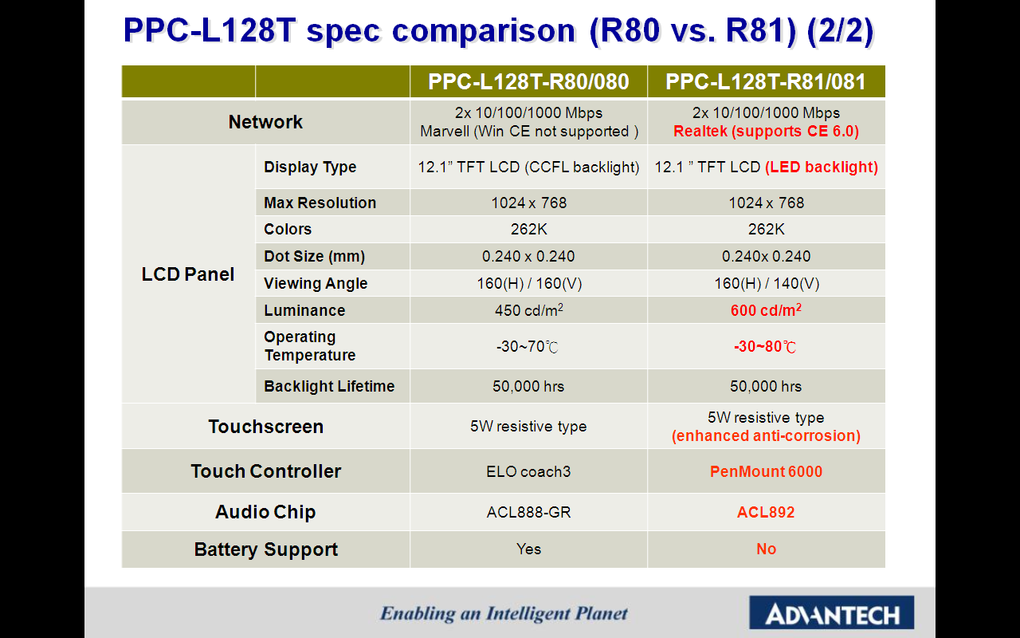

**New Energy-Saving PPC-L61T Reduces Power Consumption by 15%**

The new PPC-L61T (R71) model uses significantly less power. By employing a new LCD panel, and utilizing special Advantech technology to optimize the system, the PPC-L61T achieves up to a 15% reductionin energy consumption compared to the previous model, leading the industry in energy efficiency. Luminance has increased from 400 cd/m2 to 700 cd/m2 and the operating temperature range has been expanded to -30° to 85° C. These changes allow users to operate the PPC-L61T in a wider choice of working environments: outdoors, refrigerated warehouses, and so on. Advantech will continue its energy conservation efforts and is committed to helping businesses and organizations enhance productivity.

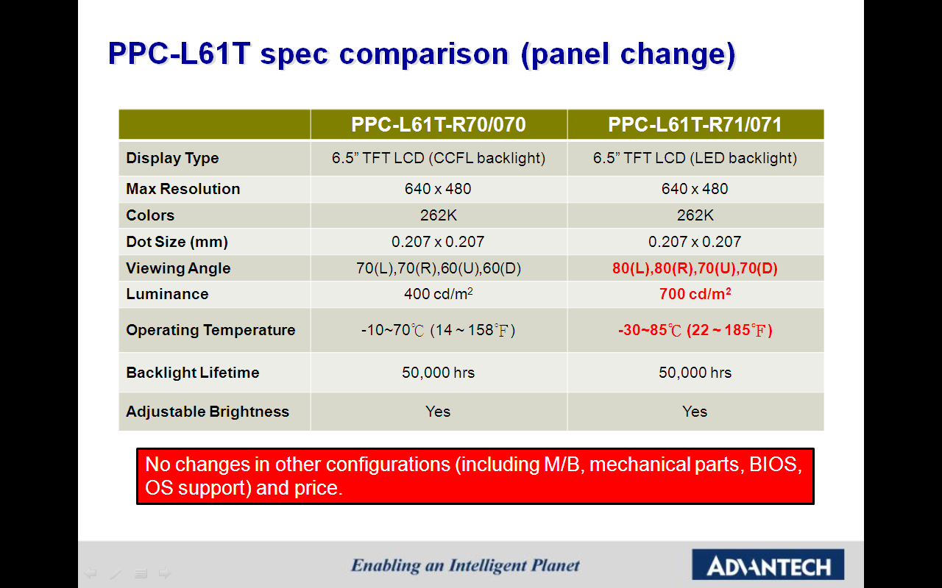

The new PPC-L128T and PPC-L61T are available now. For more information about the products, information about other Advantech Panel PCs, or general information, please contact an Advantech sales representative, or visit the website at: [www.advantech.com/applied-computing-systems/panel-pc](http://www.advantech.com/applied-computing-systems/panel-pc/)

###

**About Advantech**

Founded in 1983, Advantech is a leader in providing trusted, innovative products, services, and solutions. Advantech offers comprehensive system integration, hardware, software, customer-centric design services, embedded systems, automation products, and global logistics support. We cooperate closely with our partners to help provide complete solutions for a wide array of applications across a diverse range of industries. Our mission is to enable an intelligent planet with Automation and Embedded Computing products and solutions that empower the development of smarter working and living. With Advantech, there is no limit to the applications and innovations our products make possible. (Corporate Website: [www.advantech.eu](http://www.advantech.eu)).